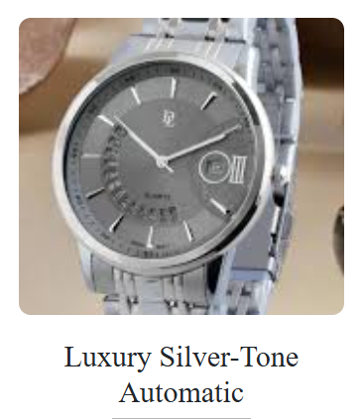

**🕰️ Product Name:** Luxury Silver Tone Automatic

**📄 Description:**  
A refined silver-tone automatic watch featuring Tissot's Powermatic 80 movement, offering an 80-hour power reserve. Its sleek design makes it suitable for both formal and casual wear.

**⚙️ Specifications:**

* **Movement:** Automatic (Powermatic 80)
* **Case Size:** 41 mm
* **Case Thickness:** 10 mm
* **Case Material:** Stainless Steel
* **Dial Color:** Silver
* **Crystal:** Sapphire
* **Strap Material:** Stainless Steel
* **Strap Color:** Silver
* **Water Resistance:** 50 meters
* **Functions:** Date display at 3 o'clock
* **Clasp Type:** Fold-over with hidden double push-button
* **Warranty:** 1-year international warranty
* **💰 Price:** Rs. 68,999